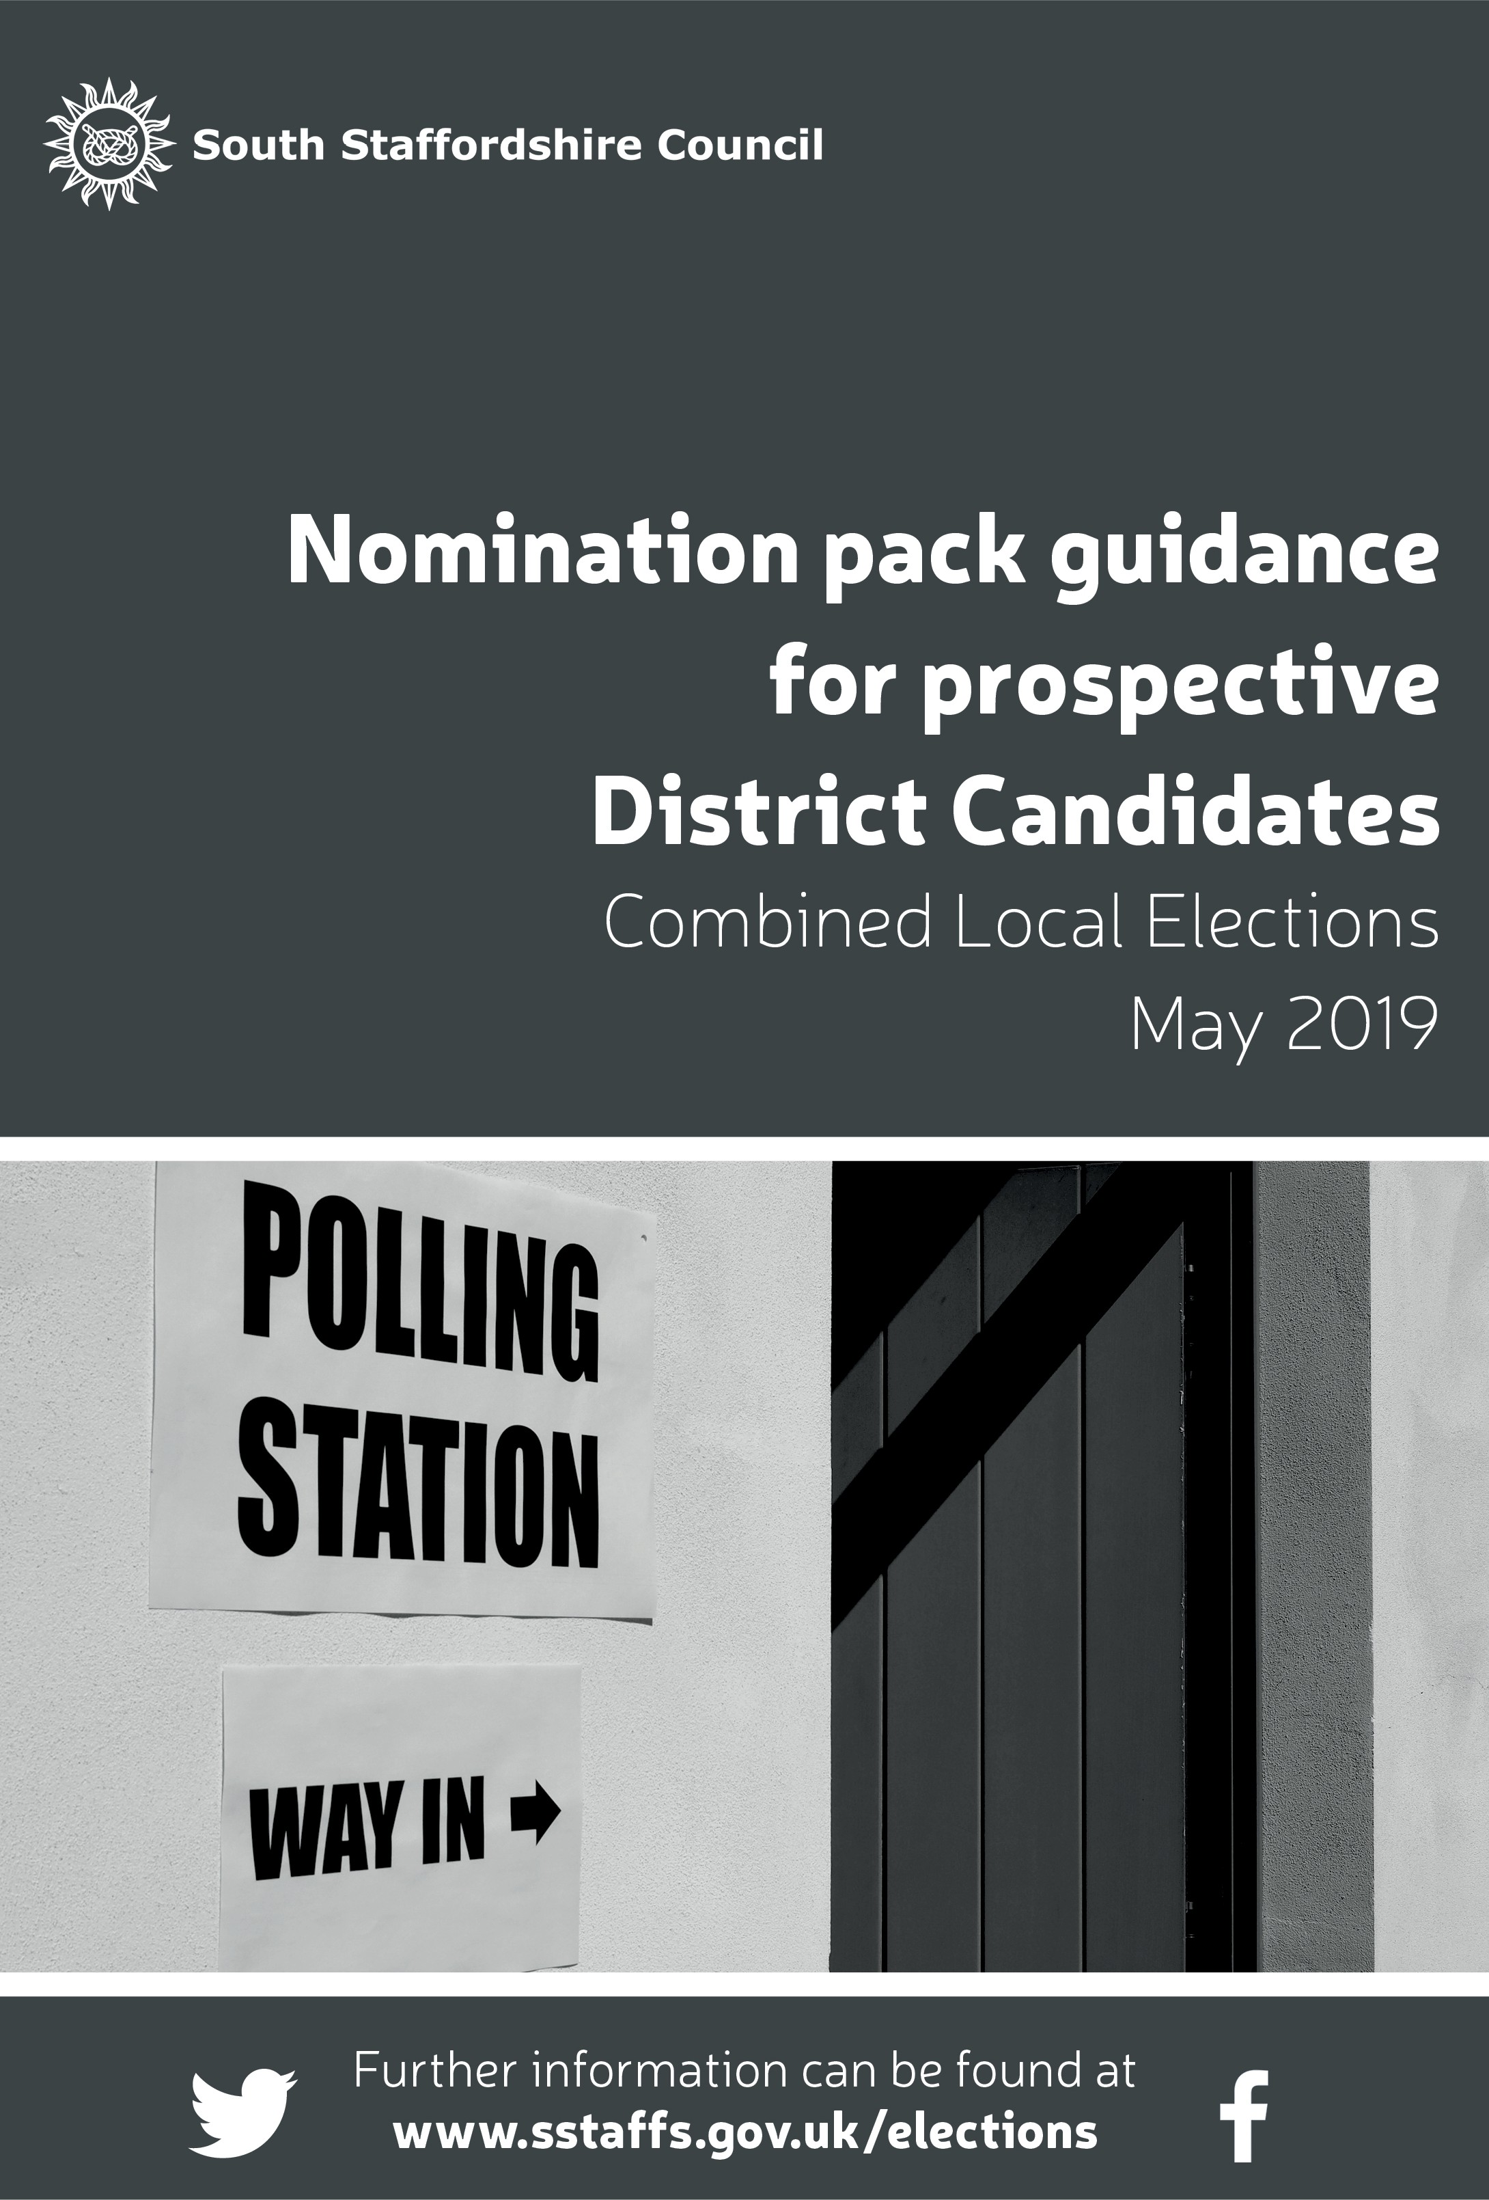



**Candidates and Agents Guide**

Staffordshire County Council Election 2025

**Contents**

|  |  |
| --- | --- |
| **Introduction** | Page 3 |
| **Receipt of the ballot boxes** | Page 6 |
| **Notification of secrecy requirement** | Page 3 |
| **Verification** | Page 6 |
| **The Count** | Page 8 |
| **The Result** | Page 9 |

**Introduction**

This guide has been developed to support Candidates and Agents through the Verification and Count process for the Staffordshire County Council 2025 election.

Dave Heywood is the (Deputy) Returning Officer (DRO) for the South Staffordshire Divisions for the Staffordshire County Election.

Lorraine Fowkes is the Assistant Deputy Returning Officer (ADRO).

**Key Information**

**Timings**

21:15 – Ground floor open to Candidates and Agents

21:30 - DRO Candidates and Agents briefing to take place on the Ground floor

21:50 - Count Floor is open for Candidates and Agents

22:00 - Polling stations are now closed, Presiding Officers to return ballot boxes to the count   
and verification commences

|  |
| --- |
| **Security** |
| Candidates and agents will be provided with a lanyard upon arrival.  This **must** be worn and visible at all times.  There will be staff members on hand to guide you around the building and it will be signposted accordingly. |
| **Maintaining the secrecy of the Count** |
| * Every person in attendance has a legal duty to maintain the secrecy of voting. * Mobile phones must be set to silent. * No photographs or filming of the proceedings is allowed on the count floor whilst the verification and count is in progress.   **Notification of secrecy requirements – the count**  Section 66 of the Representation of the People Act 1983 (as amended)  [ ... ]  (2) Every person attending at the counting of the votes shall maintain and aid in maintaining the secrecy of voting and shall not –  (a) ascertain or attempt to ascertain at the counting of the votes the number or other unique identifying mark on the back of any ballot paper;  (b) communicate any information obtained at the counting of the votes as to the candidate for whom any vote is given on any particular ballot paper.  [ ... ]  (6) If a person acts in contravention of this section, he shall be liable on summary conviction to a fine not exceeding level 5 on the standard scale or to imprisonment for a term not exceeding 6 months. |
| **Final postal vote opening session** |
| * The final postal vote opening session will take place from 20:00 on Thursday 1 May 2025 in the Council Chamber. * This opening will include any postal votes collected by Polling Station Inspectors throughout the day. * Polling Station Inspectors will carry out one postal vote collections early afternoon. * Any postal votes handed in after the Polling Station Inspectors final visit will arrive at the count venue after the close of poll with the Presiding Officer. * The final postal voting session will finish once all postal votes have been accounted for, and the votes will be taken to the relevant table for verification. |
| **Refreshments** |
| * Drinks will be available in the Café area (ground floor). * No refreshments are allowed on the count floor. * No refreshments will be served from the Café |
| **Ballot box receipting** |
| * Ballot boxes will be receipted on the ground floor of South Staffordshire Council, Codsall Community Hub, Wolverhampton Road, WV8 1PX after the close of poll. |
| **Media** |
| * Media may attend the count, and you may be approached for an interview. Our Communications Manager, Kirsten Rawlins will be on hand to deal with any queries. |
| **Wifi information** |
| Connection – SStaffsGuest  Password – W1f1@c355 |
| **Divisions** |
| The divisions will be counted on the following tables:  Table 1 - Codsall  Table 2 - Kinver  Table 3 - Penkridge  Table 4 - Perton  Table 5 - Cheslyn Hay Village, Featherstone & Shareshill  Table 6 - Wombourne  Table 7 - Great Wyrley and Essington  Table 8 - Brewood  Please note as divisions are completed and announced, staff will be asked to support other tables. |
| **Verification** |
| * At 21:50, the count space on the second floor will be opened to allow entrance for Candidates, Agents, and guests. * Verification of the ballot papers will commence at 22:00, starting with the postal vote ballot boxes. * Although we aim to complete this process as soon as possible we prioritise accuracy over speed, to ensure the verification process is correct and all votes are accounted for. * A verification statement will be produced and displayed on the count floor on a designated noticeboard. |
| **Count** |
| * As the verification and count of all divisions will be on a rolling basis, no fixed timings can be provided. * An announcement will be made for each division when counting will commence. * Doubtful ballot papers will be adjudicated regularly as the count proceeds in accordance with the Electoral Commission’s doubtful guidance. A copy of this guidance is available. * Throughout the counting process any doubtful ballot papers will be put into a doubtful tray. All doubtful ballot papers will be reviewed by the DRO or ADRO. * After being checked any remaining doubtful ballot papers will be shown to candidates before being rejected. * If you have any queries during proceedings, please speak to Lorraine Fowkes or Becky Harris. |
| **Provisional results and recounts** |
| * Candidates and agents will be advised of the provisional result. It is at this point that recounts can be requested. * The DRO will consider any recount request but, by law, can refuse the request if it is unreasonable. If a recount is approved, then an announcement will be made to advise everyone of the process. |
| **Declaration of result** |
| * The declaration of result will be made on the count floor. * A copy of the results will be made available on social media, the website and a hardcopy will be placed on the noticeboards on the count floor. |

**The receipting of the ballot boxes**

The correct and orderly receipt of ballot boxes and materials from polling stations is a key component of an accurate verification process. This commences immediately after 22:00 on Thursday, 1 May 2025.

1. A ballot box receipting team will be appointed to receipt the paperwork and ballot boxes from the polling stations. The delivery and receipt of ballot boxes will have been explained in detail to the Presiding Officers to ensure they are familiar with what will be required of them when they arrive at the venue.

2. All Ballot Boxes will be received through the main entrance of the Council Offices. The following will be receipted from the Presiding Officer:

* The ballot box
* The ballot paper account
* Any postal votes handed in at the polling station (these will be in a labelled envelope)
* The Marked Register
* The assorted bags of stationery including the unused ballot books.

It is at this point that the ballot receipting team will ensure that all of the stationery is provided by the Presiding Officer.

Another team will then start to open the unused ballot books and stationery and complete a set of paperwork. This is an important unseen part of the verification, as if there is a later problem with the figures on the ballot paper account, it can be compared against the unused paperwork. This provides a further check on the validity of the verification and count numbers.

3. The ballot boxes will then be securely transported to the second floor to begin being verified. Verification will begin as soon as the boxes arrive on the second floor.

Each ballot box will be transported to the count floor by a designated ballot box runner. They will access the second floor by staff only staircases. Each Runner will come back downstairs via the main staircase. They will be in high visibility vests on the night.

**The Verification process**

Verification will start at 22:00.

Verification is where the DRO has to ensure that the ballot papers returned from the polling stations tally with the return provided by the Presiding Officer responsible for the ballot box throughout polling day; and also, to double check the number of ballot papers received from the postal vote opening sessions.

The verification stage does not consider how the voters have completed their ballot papers. It is purely a numerical process but is very important because it establishes what has been received at each polling station throughout polling day, providing us with a clear audit trail.

Consequently, establishing the exact number of ballot papers is of paramount importance because these figures will underpin the actual count itself.

There will be eight experienced Head Counters who will each have their own team of counters to manage, with the clear message that we want accuracy over speed. There will be two Zone Supervisors who will oversee the proceedings on the count floor.

**Stage 1**

* The first exercise the Head Counter will be asked to do is to verify the postal vote ballot papers already received by the DRO prior to and including polling day.
* The postal vote ballot boxes will have been distributed to the head counter following the postal vote opening sessions undertaken prior to the close of poll. As the poll has now closed all ballot papers will be dealt with face up.
* Once the figures tally, the Head Counter retains the postal votes in a clear box, and they will be added to the rest of the ballot papers received from the polling station as the count commences.

**Very important:**

1. Once the postal votes are verified the team moves onto the polling station boxes allocated taking each box in turn emptying the contents carefully and slowly onto their table. Each ballot box is labelled with the polling station number and area.
2. Once arranged into neat piles, the teams then count the number of ballot papers and band into batches of 10.
3. Remember, this is not a vote count, merely a count of the number of ballot papers received in the box. This must be completed carefully.
4. Once double checked the papers are further banded into packs of 10 to make 100.
5. Once counted the supervisor completes the verification slip for each ballot box received with the number counted.
6. The totals should agree with the ballot paper account received from the polling station.
7. If the figure does not tally, the Head Counter will recount the papers, and the process is repeated until the DRO determines that any disparity is or is not acceptable.
8. lt is this tallying of the totals that is so important because it ensures a strict audit trail from the polling station through the verification to the count.
9. Once completed, a formal verification statement will be compiled and produced for the Candidates and Agents and displayed on the verification board. The verification statement details the returns from the polling stations and the postal vote returns. A calculation of the turnout will also be made. These figures will be formally recorded and declared by the DRO.

**Under no circumstances can Candidates or Agents touch or handle any ballot papers.**

**The count process**

The count will commence once verification is completed.

This election uses the first past the post system for counting votes.

The DRO will collate the totals from all the ballot boxes and then ascertain the winning candidate.

Count Assistants will be sorting the ballot papers into the candidates and taking out any doubtful ballot papers which will be put in a doubtful tray.

Once all the ballot papers have been sorted, they will be instructed to count into 10s and then 100s for each candidate with the totals passed to the Head Counter.

All doubtful papers are filtered, and the Head Counter ensures that these are kept in a separate tray for the DRO to go through with the Candidates and Agents present. The legislation provides that you must reject a ballot paper which:  

* does not bear the official mark (not the unique identifying mark)
* votes are given for more than one candidate
* on which anything is written or marked by which the voter can be identified (except the printed ballot paper number or other unique identifying mark)
* is unmarked or void for uncertainty

However, the legislation states that unless the way the ballot paper is marked identifies the voter, a ballot paper on which the vote is marked in the following ways must not be rejected if the voter’s intention is clear:

* elsewhere than in the proper place
* otherwise, than by means of a cross, or
* by more than one mark

In addition, ballot papers may require further consideration where there is:

* anything unusual about it (for example, any ballot paper that appears to have been altered, either with a clearly different writing instrument or with correction fluid)
* any tears or damage to the ballot paper

Ballot papers that are torn or damaged are able to be accepted as a valid vote as long as the paper still contains the official mark, and the intention of the voter is clear and none of the other grounds for rejection apply.

Those votes considered valid for a candidate are added to the totals and the result compiled.

Further information and examples of doubtful ballot papers have been issued by the Electoral Commission – copies available on the count floor.

Once all the tables have completed the count the provisional result will be shared with the Candidates and Agents. Only after the provisional results have been shared with the candidates will the DRO make the official declaration of results on the count floor.

**The Result**

All results will be announced from the stage on the Count floor. An announcement will be made on the count floor and on the ground floor that the results are ready to be declared.

Results will be published on our Council website, Social Media pages as well as notice boards on the count floor.